Worksheet


Items highlighted in yellow are tasks for you to complete
Items in Blue italics are help tips

EXAM Graphic Design Y9

NAME: ________________________________ Teacher

TASK: You are to create a LINEAR power point presentation with the theme “Winter Breaks 2017” based on the Winter Breaks booklet put out by the WA Tourism Commission.

In the booklet provided there are 4 sections – Perth & Surrounds; Southern; Heart-lands; and Northern. Heartlands and Northern will be combined as there is not much info.

YOU ARE ONLY REQUIRED TO DO ONE AREA AS CIRCLED ABOVE

RESOURCES:
- a copy of the Winter Break’s 2017 booklet
- Scanned Graphics.
- In it there are 4 sub-folders appropriately labeled for each section. They containing
- the cover page of the booklet;
- files labeled with a page number which include the opening page for the section, and two pages from the section with hotel / motel information.
REQUIREMENTS:
- 5 Screens following this general layout–
1) Title Page
2) Index page – may contain some general information about the area (map?);
3 & 4) Two pages covering motels / hotels / resorts from your section – either from the booklet or from the scanned page;
5) Concluding screen with an appropriate soft sell.
- In your Task 3 Folder create a new folder called Graphics and copy the graphics from this test
- A combined Concept Map / thumbnail sketch showing what you are planning to put on each screen. A suitable page is provided. This needs to be completed before you start assembling your Presentation.
Your teacher will sign them off at the end of the first period.
- There should be a transition effect (animation) between at least 3 of the screens;
- Some text animation’s (not over done).
- Not all hotels / motels have pictures associated with them – be selective when choosing which ones to write about.
- There must be evidence that you have used a graphic-editing program to do something to the scanned image(s).
For example, as a minimum you will have to cut a picture out of the page of scanned text (called “Crop”). NOTE: text needs to be typed in. THERE SHOULD BE NO TEXT ASSOCIATED WITH A GRAPHIIC do not expect a whole scanned page to be inserted!
- One title lettering / graphic you did yourself using something other than Powerpoint.

Day 1:

Morning: Perth to Bunbury
An early morning start will give you the best chance of meeting the friendly wild dolphins of Bunbury for a memorable close encounter.
Head south from Perth on the Kwinana Freeway and Forrest Highway and you’ll reach the Bunbury Dolphin Discovery Centre within just two hours.
Take a swim tour with the dolphins, join a dolphin eco cruise, learn more about dolphins and local marine life inside the centre, or head for the interaction zone at the shoreline, and wait for the dolphins to come to you. 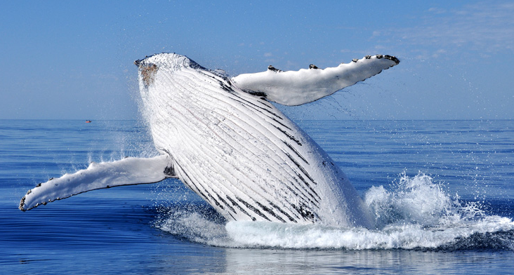
Whale watching near Busselton

Afternoon: Bunbury to Busselton and Dunsboruough
Stay in Bunbury for lunch at a cafe, restaurant or brewery, or make the 50-minute journey to Busselton for lunch overlooking Geographe Bay and the longest timber jetty in the southern hemisphere – Busselton Jetty.
Take the 1.8-kilometre jetty walk, or ride the train and take a tour of the Underwater Observatory – your window to Australia’s greatest artificial reef.
From here, it’s another 25-minute drive to reach Dunsborough for your overnight stay.

Day 2:

Morning: Dunsborough
If you’re visiting between the months of September and December, join a whale watching tour to witness the annual migration of the humpback and southern right whales along Western Australia’s coast.
January to April is a good time to enjoy the region’s stunning beaches, including the calm sheltered waters of Meelup Beach and Bunker Bay.
Real people real stories
"I Jumped in and Was Instantly Blown Away by What I Saw"
By @efrikaaa
#justanotherdayinWA

Afternoon: Dunsborough to Margaret River
Continue south on scenic Caves Road and take your pick from the region’s many fine wineries and breweries for lunch.
You can easily spend the whole afternoon indulging in premium wines and fine artisan foods, hopping between the cellar doors and gourmet produce stores of Margaret River.
Hand pick your ingredients for a cook-your-own dinner, or dine on the fine creations of the region’s many award-winning chefs. See the Australian Good Food Guide for inspiration.

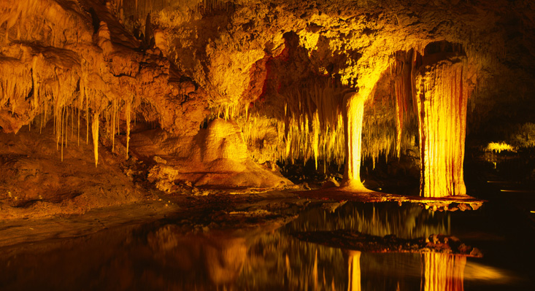
Lake Cave, Margaret River

Day 3:

Morning: Margaret River forests and caves
Breakfast in Margaret River town, and browse the high street for art and crafts, fashion and foodie treats.
Or head up to one of the most famous of Margaret River’s 40 surfing spots – Surfers Point, near Prevelly . Home to the internationally-renowned annual Margaret River Pro competition, it’s a top spot to watch the local pros in action.
Continue south on Caves Road and you’ll soon find yourself amongst the tall karri trees of Boranup Forest. Enjoy a scenic drive and a picnic surrounded by these majestic 60-metre timber giants.
Below the forest floor lie other enchanting worlds. Take a guided tour of the wild depths of Mammoth Cave, Lake Cave, or Jewel Cave – home to the longest straw stalactite on show in the world.

Afternoon: Margaret River to Augusta
Another 15-minute drive south brings you to the most south-western point in Australia, at Cape Leeuwin Lighthouse .
Join a guided tour of the lighthouse (the largest of its kind on mainland Australia), watch the waters of the Indian Ocean and Southern Oceans collide, and keep an eye out for migrating whales between June and September.
From here, you’re just an eight-minute drive away from Augusta accommodation and restaurants.

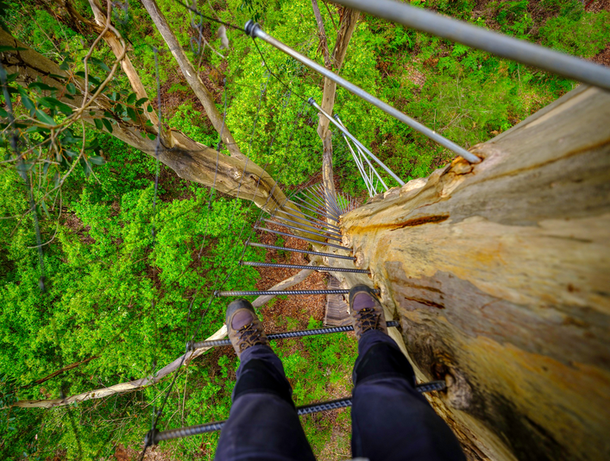
Gloucester Tree, Pemberton

Day 4:

Morning: Augusta to Pemberton
If you missed the whale watching in Dunsborough, humpback and southern right whales can often be spotted close to the shore in Flinders Bay. Or you can jump aboard a morning tour from Augusta (June to September) for memorable encounters.
In under two hours from Augusta, you’ll reach the premium cool-climate wine region of Pemberton – the perfect stop for lunch and dinner.

Afternoon: Pemberton
The best forest vantage points can be found by venturing up Pemberton's climbing trees. Originally used as fire lookouts in the 1940s, the largest (known as the Gloucester Tree) stands at 61 metres.
Nearby, the dense forests and pretty waterways of Beedelup and Warren national parks offer another great opportunity to wander the Bibbulmun Track or cycle the Munda Biddi.

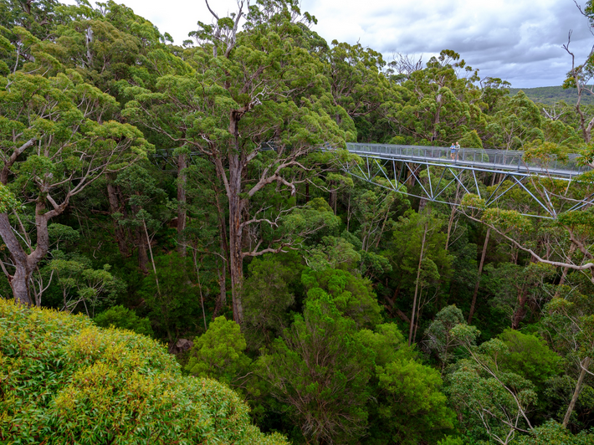
Valley of the Giants Tree Top Walk

Day 5:

Morning: Pemberton to Walpole
Follow the Vasse and South Western Highway from Pemberton to Walpole, and the Valley of the Giants Tree Top Walk.
This unique walkway (the first of its kind ever built) leads you on a gentle climb, 40 metres above the forest floor, to reveal breathtaking views of Western Australia’s 400-year-old tingle tree giants.

Afternoon: Walpole to Denmark
Heading east to Denmark, the 40-minute scenic drive brings you to the spot where the tall-timber forests meet the clear green-blue sea.
Here, in William Bay National Park, you can swim and snorkel in one of nature’s most inviting swimming pools, Greens Pool, and take a scenic walk to meet some curious bathing giants at Elephant Rocks .
Along the 20-minute drive into Denmark, stop by the cellar doors and gourmet produce stores to pick up some evening treats before taking a table at one of Denmark’s restaurants for dinner.

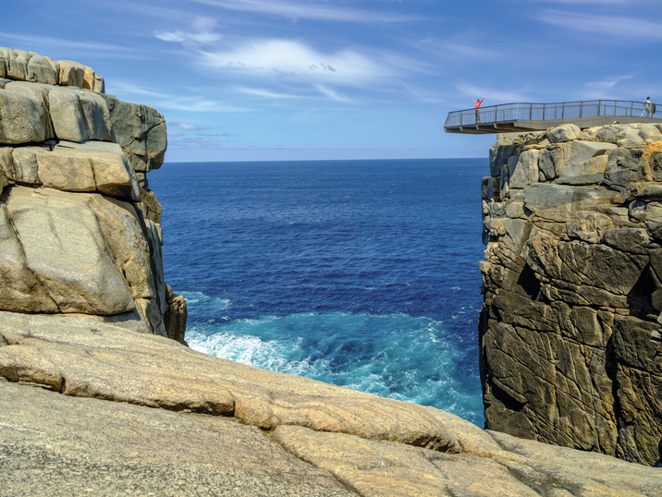
Torndirrup National Park

DAY 6:

Morning: Denmark
Follow Mount Shadforth Tourist Drive into the rolling hills above Denmark town for a morning feast of local wines, arts, delicious produce and breathtaking mountain-to-ocean panoramas.

Afternoon: Denmark to Albany
It’s a 50-minute drive east from Denmark, through Albany, to reach one of the most dramatic coastlines in Western Australia – Torndirrup National Park – home of The Gap, Natural Bridge and The Blowholes. From July to October, these tall cliffs make a top whale watching spot too.
Return to Albany and take your pick from the restaurants, taverns and accommodation options among the town’s 50 heritage buildings.

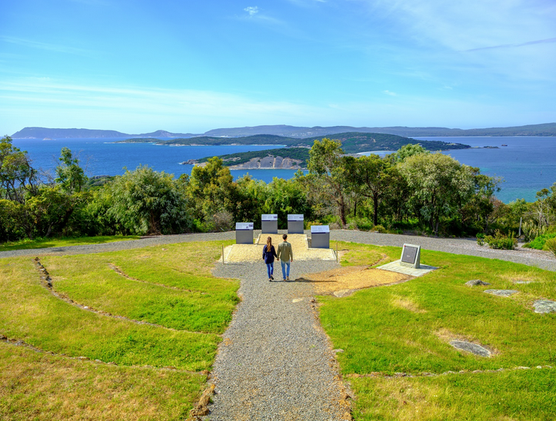
Anzac Centre, Albany

DAY 7:

Morning: Albany
Spend the morning exploring the spot where the first European settlers set foot in Western Australia and where the first ANZACs departed Australian soil, bound for the First World War. You can discover almost two centuries of dramatic whaling, convict and settler history on the heritage trails and by visiting Albany’s museums.
Head out to the historic whaling station at Discovery Bay - the only museum of its kind in the world to be hosued in a formerly fully-operational whaling station.
Or step inside the boots of an ANZAC at the state-of-the-art National Anzac Centre and follow their personal journey from recruitment, through training and in conflict at the battlefields of Gallipoli, the Middle East and the Western Front.
A weekend visit to Albany will bring a bonus treat – a taste of the region’s fresh local flavours at the iconic Farmers' Markets.

Afternoon: Albany
From Princess Royal Fortress and Mount Clarence, you can take in amazing views of the town, coast and wind farm. Or you can view the entire coast in all its rugged beauty on a scenic helicopter flight.
For more historic insights, head up to Mount Romance to experience one of the oldest industries in Western Australia – the branch-to-bottle processing of sandalwood.


The Kodja Place

DAY 8:

Morning: Albany to Kojonup
A one-hour flight gets you direct from Albany back to Perth.
If you’re making the return journey by road, make the one-hour-forty-minute drive north following the Albany Highway to The Kodja Place.
Browse the Kodj Gallery and gift shop, featuring local and regional Noongar paintings, boomerangs, didgeridoos and hand-painted pottery.
Experience the tradition of billy tea and damper on a guided tour and enjoy lunch at the café, overlooking the Australian rose maze.

Afternoon: Kojonup to Perth
From here, it’s a three-hour drive through the vast open spaces of the Wheatbelt to Perth. Break your journey with a refreshment stop in the outback town of Williams and its interpretive woolshed.
SUGGESTED PROCESS:

- Use Explorer to create a new folder and copy graphics as required.
- Open one of your section’s graphics to see what it looks like.
- Repeat for the other graphics.
- Locate your pages in the booklet from which your graphics were scanned.
- Sketch your concept map / thumbnail sketches.
- Edit the graphics you want to use by removing the text.
- Create your pages. Add the effects.
- Don’t forget to save your work regularly (Into Task 3).

Concept map and thumbnail sketches on next page.

On this page you need to draw your concept map & thumbnail sketches.

